**INFOGRAPHIC**

[**https://thebestbowlrecipe.blogspot.com/2023/09/how-to-boost-your-immune-system.html**](https://thebestbowlrecipe.blogspot.com/2023/09/how-to-boost-your-immune-system.html)

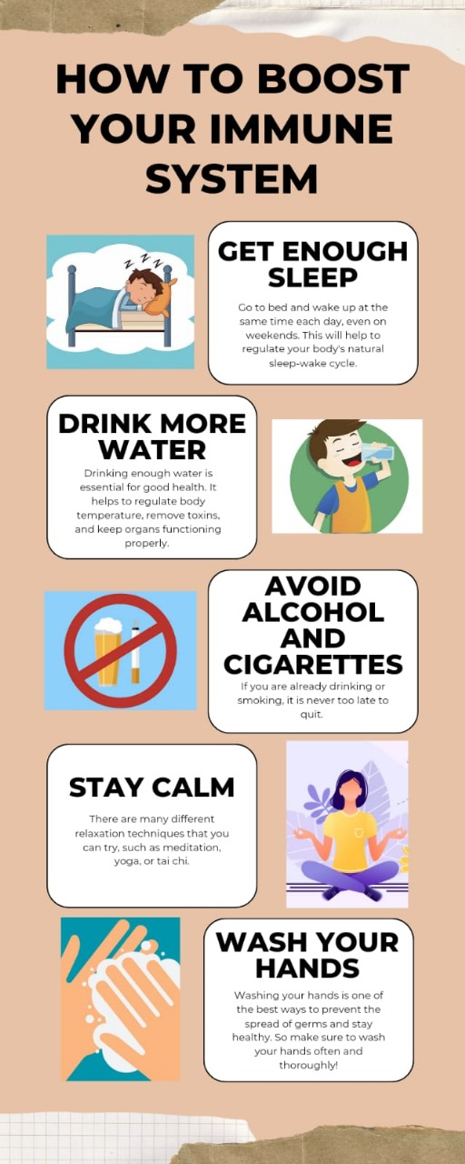

**EMAIL NEWSLETTER**

[**https://thebestbowlrecipe.blogspot.com/**](https://thebestbowlrecipe.blogspot.com/)



**BLOG**

[**https://thebestbowlrecipe.blogspot.com/**](https://thebestbowlrecipe.blogspot.com/)

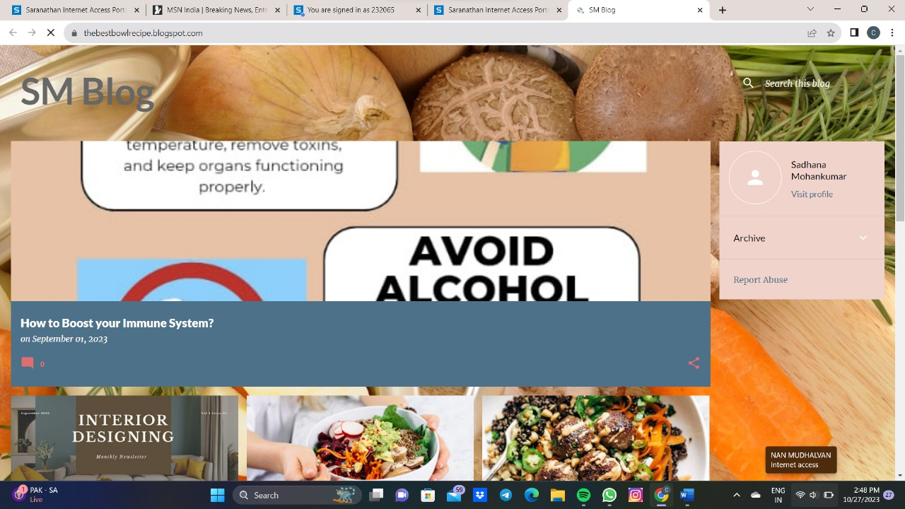

**FACEBOOK**

<https://www.facebook.com/profile.php?id=61552679826772>

